What is Plantar Fasciitis?
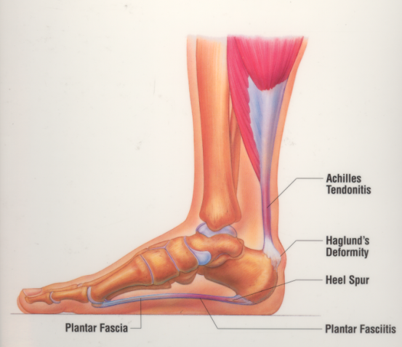
Heel pain is one of the leading causes for patients to visit North Idaho Foot and Ankle Institute. The plantar fascia is a
ligament that extends from the heel to the ball of your foot. This band pulls on the heel bone, raising the arch of your foot as it
pushes off the ground. If your foot functions incorrectly, the plantar fascia may become strained. The fascia may swell and its tiny fibers may begin to fray, causing plantar fasciitis.
Symptoms - With plantar fasciitis, the bottom of your heel may hurt when you stand, especially first thing in the morning. Pain usually occurs on the inside of the foot, near the spot where your heel and arch meet. Pain may lessen after a few steps, but it comes back after a period of rest or with prolonged activity.
Causes - Plantar fasciitis is often caused by poor foot mechanics. If your foot flattens too much, or pronates, the fascia may overstretch and swell. If your foot flattens too little, or supinates, the fascia may ache from being pulled to tight. Tight calf muscles are also a contributing factor that cause early heel lift when walking, with resulting increased tension on the plantar fascia.
Another factor in the severity of plantar fasciitis is obesity. While not the direct cause, weight will considerably increase the strain on the foot and plantar fascia.
A final factor is shoe gear. If your shoes are ill-fitting, worn out, or don’t provide proper support for your foot type, they can contribute to the symptoms of plantar fasciitis.
Heel Spur - The heel spur is a ridge of bone that forms to reinforce where the plantar fascia attaches to the heel bone. The spur can become enlarged in response to chronic tugging and tearing of the plantar fascia from the heel. A heel spur is not the cause of heel pain, but the result of chronic plantar fasciitis. Heel pain is almost always resolved without removing the heel spur.
Treatment - The chronic inflammatory process must be broken before much progress can be made with stretching and arch support. This can be achieved with oral anti-inflammatory medication and a cortisone injection.
We recommend Aleve (Naproxen) 2 pills twice a day or Advil (Ibuprofen) 3 pills 3 times a day for 7-10 days. Take as directed with food and discontinue if your stomach gets upset. These medications should be used with caution if you have preexisting high blood pressure and should not be taken if you are taking Coumadin, have a history of kidney disease, acid reflux, stomach ulcers or GI bleeding. Never take more than the recommended doses.
A cortisone injection in the foot is not nearly as painful as injections in large joints such as the knee. While the cortisone will not fix the mechanical causes of plantar fasciitis, it is quickly effective at breaking the painful inflammatory cycle and provides a window of several weeks to months relief to resolve calf tightness, poor arch support etc.
Support the Arch – This can be achieved with taping or strapping the foot, a brace or arch supports. Over the counter arch supports are made from a generic mold for the average foot. They are a less expensive option that will usually last about a year. Custom arch supports (orthotics) are built from a cast of your foot, with measurements from your biomechanical exam and x-rays, using high grade materials that can last 6-10 years.
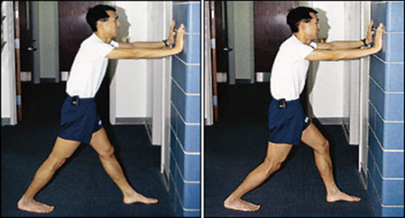
Stretching –This step is often overlooked, however is critical to resuming normal foot and ankle function. Calf muscle tightness nearly always aggravates plantar fasciitis. Stretching should be held for at least 45-60 seconds and performed 3-4 times per day. The more you stretch, the faster you will see results.

Gastroc Muscle Stretch – Keeping back leg straight, spine straight, with heel on the floor, lean into the wall until a stretch is felt in the calf.

Soleus Muscle Stretch – Standing with both knees bent, spine straight, and the involved foot back, gently lean into the wall until a stretch is felt in the lower calf.

Rest - Plantar fasciitis is a chronic inflammatory process and will recover quicker the more you can allow the damaged structures to rest. If you exercise, decrease your mileage and switch to lower impact activities. If you work on your feet, minimize standing time if possible. Failure to decrease your activity will delay your recovery.
Ice - Icing will relieve inflammation and provide moderate pain relief, however it will also tighten the tissues. Use ice at the end of the day, or when you will be off your feet for several hours. You can roll a frozen bottle of water under the arch to stretch the plantar fascia and ice in one step. Do not use heat at the end of the day.
Shoes - Running shoes provide the most support and cushion for your feet. Shoes are designed for 3 foot types:
Motion Control – For severe flat feet or people over 200 lbs.
Stability – For mild to moderate pronation (majority of people)
Neutral – Offer no stabilizing structures, cushion only for neutral and high arched feet.
List of recommended shoes: http://aapsm.org/runshoe.html
Avoid stairs, ladders, walking barefoot and wearing unsupportive shoes.
Plantar Fasciitis will take 12-16 weeks to resolve completely. If symptoms do not begin to improve after 3 weeks, we
will consider night splints, cast immobilization and physical therapy. Surgery is extremely rare and a last resort for heel
spurs and plantar fasciitis.

